Data Analytics in Smart Aquaponics Systems

Written by: Subrata Garai

2017

TD



Table of Contents

What is Aquaponics? 1

Brief History 3

Design of a basic Aquaponic System. 4

Different Types of Aquaponics Systems: 6

Automaton in a SMART Aquaponic System: 9

Understanding of Plant Nutrients in Aquaponics System: 11

Data Life Cycle of an Aquaponic System 12

Analytics approaches to Aquaponics Data: 13

Other areas where Data Science can help: 19

Conclusion: 21

Acknowledgements: 21

What is Aquaponics?

In short, Aquaponics is a system where Fish and Plants grow together in one integrated system.

**Aquaponics** = **aquaculture** (raising fish) + **hydroponics** (soil less cultivation of plants in water).

Aquaponics is the mutually beneficial integration of hydroponics (e.g., soilless systems for crop production) and aquaculture (e.g., aquatic animal farming) to simultaneously produce plant and animal products. In an aquaponic system, aquatic animals excrete waste, bacteria convert the waste into nutrients, and plants consume and remove the nutrients and improve water quality for the aquatic animals. A brief history of hydroponics and aquaculture helps provide a context for how and when aquaponics was established as a field.

Aquaponics is a –

* A sustainable way of farming food using very few inputs to produce a wide range of healthy and high value foods all year round.
* The growing of fish or other aquatic organisms with plants in a controlled environment, optimising energy, water and nutrient use to produce the maximum amount of protein and vegetables in a given area.
* Fish wastes provide nutrients for the plants which in turn act as a harvestable filter system, cleaning the water so it can be continuously recycled. Off-cuts from plants are composted and the worms fed to the fish creating a completely closed-loop production system.

With Major Benefits as –

* 90% less water use than conventional agriculture.
* Combined technologies minimise energy use & systems often incorporate renewable energy technologies.
* Closeness to markets: freshest food with minimal transport emissions.
* No fertilisers or herbicides required & pesticides are replaced with biological control.
* Fish meal replaced with worms and insects from composting of plant off-cuts.
* Maximum plant densities and year round growing = huge yields.

Brief History

Aquaponics applies methods developed by the hydroponics industry. The development of hydroponics can be traced to work by Dr. William Gericke at the University of California in 1929. Chemical salts dissolved in water are the source of nutrients in hydroponics systems. Most hydroponics operations are performed in controlled environment facilities, such as greenhouses, which were developed following World War II as an industrial approach to intensively grow food crops. The introduction of plastics in the 1940s, and particularly clear polyethylene as a cover for greenhouses, was an important development. It is common for commercial aquaponic operations to use greenhouses and controlled-environment agriculture methods to increase crop production yields, essentially drawing on methods developed by hydroponics practitioners.

Aquaponics was also influenced by work in the early 1970s by aquaculture researchers who experimented with raising fish in land-based tanks with continuously recycled water (e.g., recirculating aquaculture systems or RAS). A major challenge for recirculating aquaculture was the accumulation of nitrogen compounds, a potentially toxic by-product of fish waste. Investigators experimented with soilless plant systems as a means of treating fish waste and removing nitrogen compounded, which marked the beginnings of contemporary aquaponics. Engineers have since developed a variety of bio filters to treat fish waste that do not rely on plants. The fact that aquaponic systems improved water quality and produced a second profit center, in the form of edible plants, is what distinguishes aquaponics from other forms of recirculating aquaculture.

Design of a basic Aquaponic System.

Aquaponics can be described as ‘closed-loop’ production in that it has the capacity to provide all inputs to the system within the system itself and to recycle its own wastes. For this reason the applications of aquaponics are almost endless… it does not require fertile soil or large water inputs and so can be practiced almost anywhere. The ecosystem approach to farming lends itself well to conservation and development projects and also to education. Systems provide interactive hands-on learning environments and offer a wide range of activities for learning and teaching in multiple subjects, carrying with it important principles about natural cycles, farming and recycling.

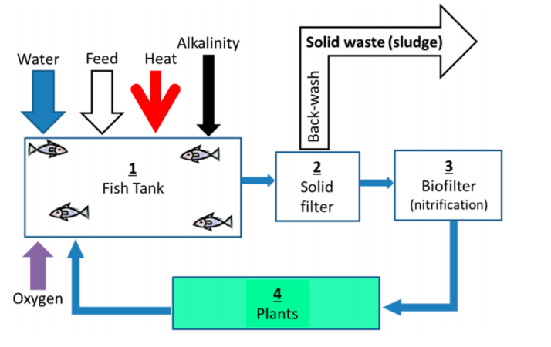

Figure 1: Schematic Diagram of a Basic Aquaponic System.

Important Elements of Aquaponic System:

(1) Fish biomass converter—the tanks where fish are grown. These need to be designed to allow for the removal of as much fish waste as possible, directly from the tanks into the solids filter.

(2) Fish waste processor—A solids filter used for the removal of suspended solids from the water that mainly consists of fish excretions and a small portion (typically <5%) of uneaten feed.

(3) Aerobic converter—a bio-filter unit used to oxidize toxic ammonia secreted by the fish to less toxic nitrate, thus allowing recycling of the system water without continuous replacement.

(4) Phototrophic (plant biomass) converter—Plant beds which use the largest area of the system. Plants are grown to produce vegetables while removing essential nutrients (e.g., nitrogen and phosphorus) through assimilation to plant biomass, thus stabilizing the water quality for the fish.

Different Types of Aquaponics Systems:

With the advancement of science and popularity of Aquaponics, different people devised different techniques to practice it. Below are three major varieties practiced:

**Media-based:** also known as the gravel bed system, the media-based aquaponics system is the simplest type to set up and can be used on a small or large scale. This is why it is the type most commonly used by backyard aquaponics enthusiasts. Containers are filled with small rocks, usually expanded clay pebbles which are porous to absorb water and air, and then seedlings are planted directly into these. Water from the fish tank is circulated through the container to allow the plants to access the nutrients. The rocks act as a biological filter as well as a solids filter, eliminating the need for extra equipment.

Special netted growing pots can be used for your seeds or seedlings. These pots can be filled with perlite, coir, peat moss or the clay pebbles and plant into them. These pots are then placed into a larger container which has been filled with the expanding clay pebbles, making sure the netted sides are covered by the media. Media-based aquaponics systems hold plants firmly and so are ideal for growing fruiting plants.

There are two different ways this type of aquaponics system can be operated. The first method pumps a continuous flow of water through the media bed from the fish tank and back into the tank. The second is a process called flood and drain or ebb and flow, where water is pumped into the bed to a depth of about 10 to 12 inches (20 to 30 cm) and then drained away. A timer controls the flooding and draining sequence.

**NFT system:** or Nutrient Film Technique is a common method used in hydroponics that is best suited to a large-scale aquaponics production. This is because of the expense of setting up the system of PVC pipes and mechanical filtration needed to operate the system. Because there is not the surface area exposed to the air, as in the media-based system, a biological filter is needed to allow the beneficial bacteria to develop and convert the fish wastes into plant nutrients. Solids filtration is also needed to deal with the solids in the fish waste; this is usually set up in a separate tank through which the water passes before going through the plant pipes.

In the NFT system, plants are held in netted growing pots which are suspended through holes cut in the pipe. A thin film of nutrient-rich water is run along the bottom of enclosed gutters so that the roots can reach it. It is really only suited to plants that have a small root systems, such as leafy green vegetables.

**Deep Flow:** also called Deep Water Culture (DWC) or the Raft system, this is another commonly-used method in hydroponics. This system involves the use of a foam ‘raft’ that floats on top of the water. It is a popular choice for both commercial and backyard aquaponics because it is relatively cheap to set up and operate.

A container or channel is used to hold the water as it is pumped through from the fish tank, after it has been filtered to remove any solid waste. Plants are held in holes made in the raft, so their roots dangle down into the water. This method uses high volumes of water which provides stable water temperatures for the plants and fish. It is the method most often used in commercial aquaponics operations because of the ease with which the plants can be tended and harvested. Again, it is better suited to growing herbs and leafy green vegetables than plants with bigger root systems and fruiting varieties.

This type of system can easily be adapted for home garden use by simply floating a Styrofoam tray on top of a fish tank. Just cut holes in the tray and suspend the plants, or plants in netting pots, through the holes so the roots are in contact with the water. Choose fish varieties that are not voracious plant eaters to avoid having plants’ roots eaten away.

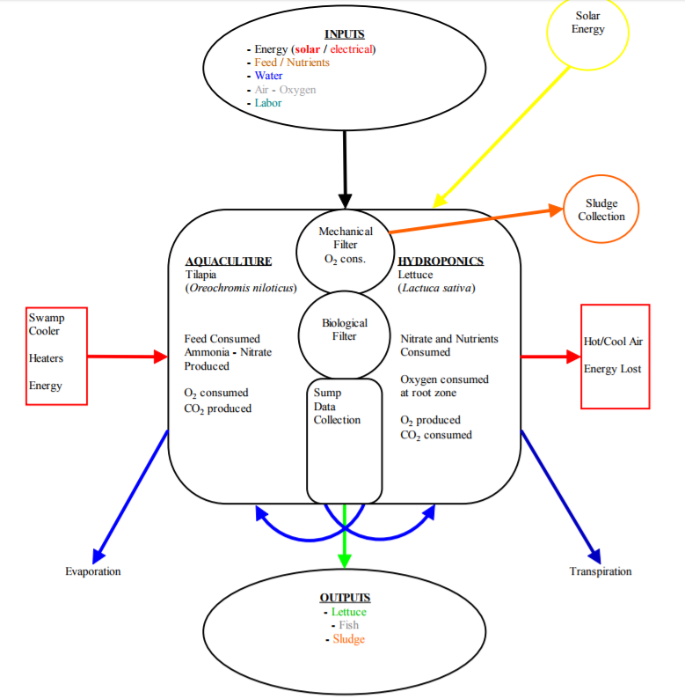

Figure 2: Common elements of any aquaponic system

Automaton in a SMART Aquaponic System:

As Aquaponics Systems demand regular supervision, there is a plenty of scope for automation. Tasks to be performed, repetitive in nature can be automated by adopting different techniques. Below are some of the tasks to be performed regularly in order to maintain good health of an Aquaponics system.

Feeding the Fishes

Fish are an essential part of any aquaponics system, so it’s important that they stay fully nourished. They should be fed twice a day (or at least once), once in the morning and again before sun down.

An automatic fish feeder can be used to perform this activity.

Check the Temperature of Fish Tank

It’s essential that you have the correct water temperature in your fish tank to make it the ideal environment for the aquaponic fish species that you have.

A temperature probe can be installed to show the water temperature of the fish tank.

Check the pH Levels

The pH level in an aquaponics system determines the ability of your plants nutrient intake, the bacteria’s reproduction abilities and the health of your fish. It’s safe to say that pH is arguably the most important factor of how well your aquaponics system runs, so it needs to be checked at least once a week.

There are probes available to measure the pH level in the water of fish tank. The ideal pH level is between 6.8 - 7.0 (for new systems), and while some aquaponic systems steadily maintain this, over time, most systems pH will decrease naturally. If it falls below 6.5, it’s time to add hydrated lime or potash to increase the pH levels again.

Check the Ammonia Levels

Like pH, another important indicator of the overall health of your aquaponics system is the ammonia levels. This also needs to be checked once a week so you can spot any problems that may turn out to be disastrous.

Probes are used to detect Ammonia / Ammonium levels in water and the levels should be equal to or less than 0.5ppm. A sudden rise in this means that there might be a dead fish somewhere within your tank.

Check the Nitrate Levels

Nitrates are usually a good thing, but when they rise to unnatural levels (above 150ppm), this could mean that there are not enough plants to take in the nitrogen that’s being released by the nitrifying bacteria. This can solved this three ways – Add more plants, harvest some fish or add another grow bed to your aquaponics system.

Check The Pumps & Plumbing System

Check all the pumps and plumbing is connected and working properly for successful circulation. This should really be checked every day, while cleaning out all the pumps and pipes should be done once a month.

It’s a hassle and dirty job but it has to be done in order to maintain the efficiency of your system. A good way to clean them is to run high-pressure water from a hose through each component. Water level indicators can provide an overview if the water pumps aren't functioning properly.

Understanding of Plant Nutrients in Aquaponics System:

In any aquaponics system, the primary earth elements play a major role in plants / fish growth. Understanding of this basic general chemistry is mandatory in order to maintain the aquaponics system. There are 16 primary elements plays various role in plants growth. They can be divided into two categories –

Non Mineral Nutrients:

Oxygen (O), Hydrogen (H) and Carbon(C)

These not generally supplemented by the farmer, unless doing carbon infusion etc. These are not the elements that are added into the system for better plant growth rather they are to be consumed from the environment.

Mineral Nutrients:

Mineral elements / nutrients can be further divided into three categories as follows.

* **Primary Nutrients –** Nitrogen (N), Phosphorus (P) and Potassium (K) (rating system in any fertilizer)
* **Secondary Nutrients –** Calcium (Ca), Magnesium (Mg), and Sulphur (S)
* **Micronutrients –** Iron (Fe), Copper (Cu), Zinc (Zn), Manganese (Mn), Boron (B), Molybdenum (Mo) and Chloride (Cl-).

Although all the elements plays crucial role in a closed aquaponic system and they have to be managed properly, hardest elements to manage are - Potassium (K), Calcium (Ca) and Magnesium (Mg).

Data Life Cycle of an Aquaponic System

In this modern age, Farming and Agriculture has turned its face into data driven approaches like never before. Even big farmers are heavily relying on automation and machine learning generated data. On the contrary, Aquaponics is relatively new in the market and handfuls of farmers are actually producing in production scale.

Current market competitions exist between conventional farming vs vertical / container / aquaponics farming. This unconventional farming techniques are getting challenged every day to fine tune the designs whereas conventional farming has thousands years of experience and it is already mature. Given this landscape, data mining and data based decision making not yet much widely used in Aquaponics and other unconventional farming systems. Hence, there is huge scope of exercising data analytics techniques to explore the unknowns in this field.

Below is the schematic diagram of how data can be collected and used to control an aquaponic system. Different sensors' can be collected by a microcontroller (Arduino etc.) and to be posted to any database in any server for further analysis. Analytic models can be used to fetch insight from the data gathered and the insight can be further used to provide knowledge to farmer and can be used to feed back to the controlling system to manage the sensors activity.



Figure 3: Sample Data Life cycle of an aquaponic system.

Analytics approaches to Aquaponics Data:

Simple analysis of a N, P, K Dataset

As explained before N, P, K (nitrogen, phosphate, potassium) is three basic elements of nutrients for any plant growth. (NPK rating is available on any fertiliser brand as it states the level of basic nutrients in them).

Let's consider the below dataset where data has been collected from 6 different test blocks (plant beds), their NPK levels and yield produced. Variables are as below.

Block - which block (label 1 to 6).

N - indicator (0/1) for the application of nitrogen.

P - indicator (0/1) for the application of phosphate.

K - indicator (0/1) for the application of potassium.

Yield - Yield on plants, in pounds/plot (the plots were (1/70) acre).

Sample dataset: npk.csv

|  |  |  |  |  |  |
| --- | --- | --- | --- | --- | --- |
| Sl No | block | N | P | K | yield |
| 1 | 1 | 0 | 1 | 1 | 49.5 |
| 2 | 1 | 1 | 1 | 0 | 62.8 |
| 3 | 1 | 0 | 0 | 0 | 46.8 |
| 4 | 1 | 1 | 0 | 1 | 57 |
| 5 | 2 | 1 | 0 | 0 | 59.8 |
| 6 | 2 | 1 | 1 | 1 | 58.5 |
| 7 | 2 | 0 | 0 | 1 | 55.5 |
| 8 | 2 | 0 | 1 | 0 | 56 |
| 9 | 3 | 0 | 1 | 0 | 62.8 |
| 10 | 3 | 1 | 1 | 1 | 55.8 |
| 11 | 3 | 1 | 0 | 0 | 69.5 |
| 12 | 3 | 0 | 0 | 1 | 55 |
| 13 | 4 | 1 | 0 | 0 | 62 |
| 14 | 4 | 1 | 1 | 1 | 48.8 |
| 15 | 4 | 0 | 0 | 1 | 45.5 |
| 16 | 4 | 0 | 1 | 0 | 44.2 |
| 17 | 5 | 1 | 1 | 0 | 52 |
| 18 | 5 | 0 | 0 | 0 | 51.5 |
| 19 | 5 | 1 | 0 | 1 | 49.8 |
| 20 | 5 | 0 | 1 | 1 | 48.8 |
| 21 | 6 | 1 | 0 | 1 | 57.2 |
| 22 | 6 | 1 | 1 | 0 | 59 |
| 23 | 6 | 0 | 1 | 1 | 53.2 |
| 24 | 6 | 0 | 0 | 0 | 56 |

Objective of this analysis is to examine any possible relationship between yield (target variable) and other variables - block, N, P, K

Below are the Null and Alternative Hypothesis for this analysis:

Null Hypothesis: All six blocks means are equal —> there is no relationship blocks and yield produced.

Alternative Hypothesis: Not all six block means are equal —> there is a relationship between blocks, N, P, K and yield.

As we are testing a hypothesis with explanatory variable categorical and a response variable quantitative, we will use ANOVA (Analysis of Variances) in R language.

First, we calculate the means of yields in each block and try to examine if they are different in each blocks.





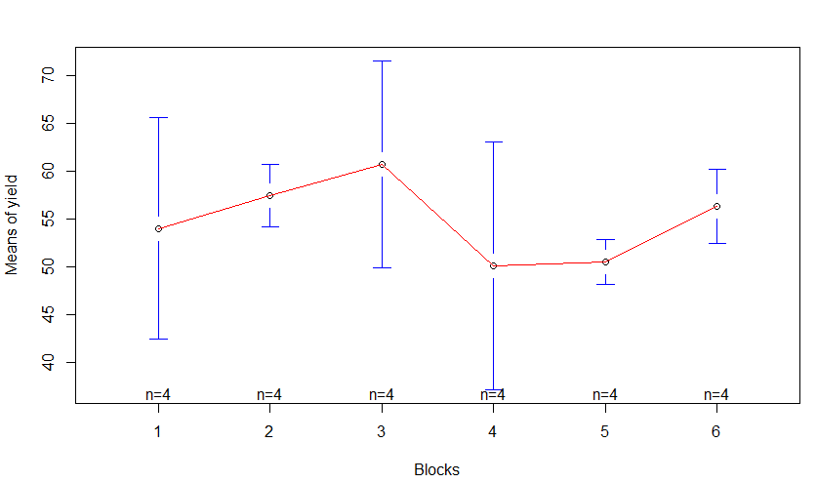

The above graph shows yield means change between different blocks, but that is not enough to provide evidence against the null hypothesis.

Let's try the boxplot:



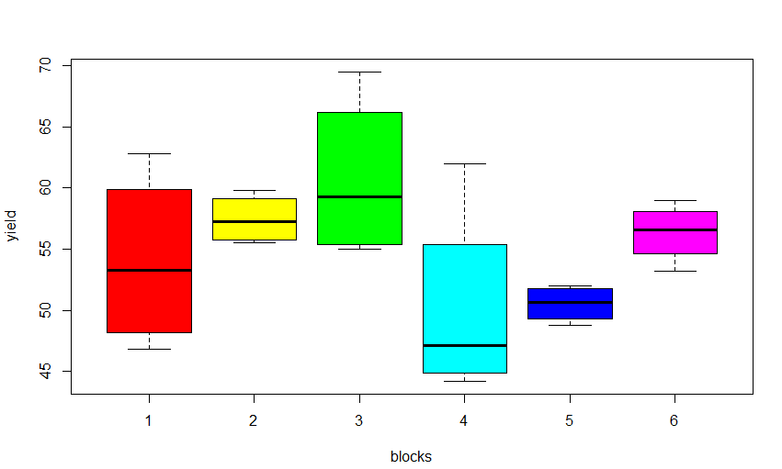

The boxplot shows that means are different (some less, others more). But it also shows that each block present a different amount of variation/spread in yield, so that there is much overlap of values between some blocks. Hence, differences in means could have come about by chance (and we shouldn’t reject the null hypothesis case). We can try ANOVA to have more insight.

The question we are trying to answer with ANOVA is: are the variations between the blocks means due to true differences about the NPK means or just due to sampling variability? To answer this question, ANOVA calculates a parameter called F statistics, which compares the variation among sample means to the variation within groups.

F statistics = Variation among sample means / Variation within groups

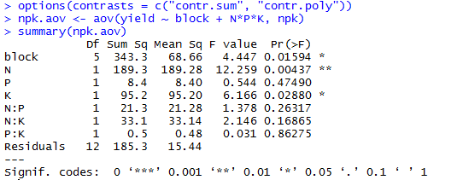

Here, for N (nitrogen), F value is 12.26, and p-value is very low too. In other words, the variation of yield means among different blocks (with different NPK values) is much larger than the variation of yield within each block (with different NPK values), and our p-value is less than 0.05 (as suggested by normal scientific standard).

Hence we can conclude that for our confidence interval we accept the alternative hypothesis that there is a significant relationship between yield and blocks with different NPK.

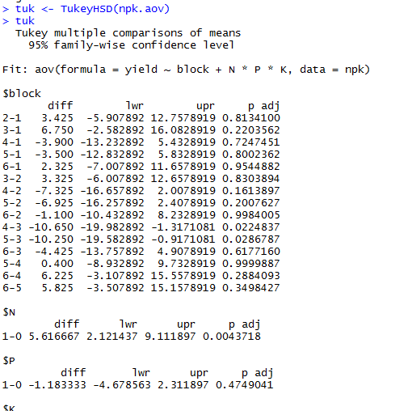

From the table above (looking at “diff” and “p adj” columns), it can be seen which blocks have significant differences in yield from others. For example, it can be concluded that:

* There is no significant difference in breast cancer new cases between block 1 and block 2 (p =0.81 > 0.05), as well as between block 2 and block 6 (p=0.99) or block 1 and block 6 (p=0.95), etc.
* THERE IS A SIGNIFICANT DIFFERENCE in breast cancer new cases between block 5 and block 3 (p= 0.02) as well as between block 4 and block 3 (p=0.02)

Finally, blocks pairs can be visualised by plotting the “tuk” object in R to and analyse significant differences. Significant differences are the ones which not cross the zero value.



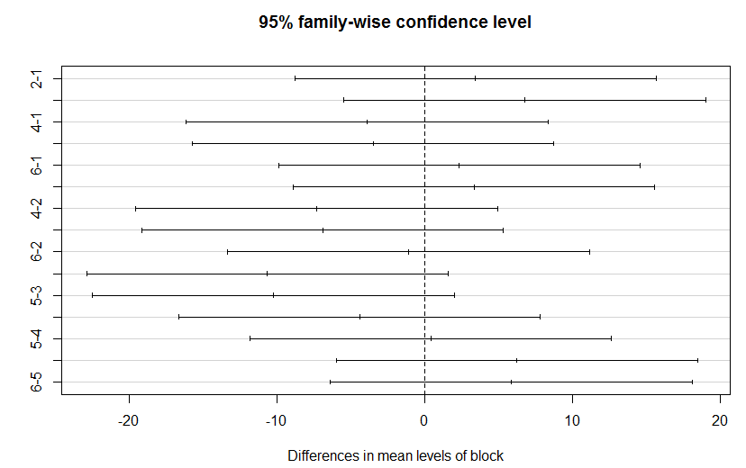

Other areas where Data Science can help:

The technique shown above is very basic in terms of actual production business problem solving. There are various spaces in Aquaponics where data driven decision making is possible to solve some business problems. Some of them are listed below.

* **Predicting / Balancing the pH level of water –** pH level in fish tank water is one of the most crucial factors for any Aquaponics system to sustain. It is comparatively easy to balance and maintain the pH level in newly build systems, whereas it gets difficult with the age of the system as multiple factors starts playing role in that. Not only nitrification, even the microorganisms' life cycle starts playing role in acidity of water. It can be trivial to build a predictive model considering the different factors. External data, like geographical / weather data would be useful to factor in the seasonality in the analysis.

Any sudden drift in pH level can be caused by one or multiple reasons.

* **Classification of growth of different vegetables –** Different kind of vegetables (as stated above) can be produced in a single aquaponics system. As different plants have their own nutrients necessity, difference in nutrients / minerals in water would have different effect on different plants. It would be interesting to measure the commonality of plants behavior.
* **Correlation and Causality –** A dead fish or a lump of unconsumed fish food in a corner of a fish tank would contribute to ammonia in the water which is toxic for plants. Mining historical data can produce useful answer to unexplained problems in the system.
* **Yield prediction –** Although Aquaponics is relatively new and scientifically established agriculture system, investors face low profitability or losses due to various reasons like insufficient knowledge on production scale aquaponics system, faulty design etc. Carefully designed business- revenue model can be helpful to investors to run a profitable business.
* **Carbon, Nitrogen and Energy Balance -** Efficient recovery of nitrogen in the suggested system is expected via: (a) aeration of the plant root environment and consequently minimization of nitrogen losses by denitrification; and (b) by recovery of organic nitrogen from the fish solid waste after its biodegradation to TAN in the anaerobic digester. Through the anaerobic digestion process organic carbon is converted to biogas so energy can be recovered. All these parameters can be hence measured, analysed and predicted for future outcome.

Conclusion:

The proposed hybridization of the aquaponic system and data analytics technologies into a closed aquaponic system is promising. It has the potential to overcome existing shortcomings related to commonly used techniques in aquaponics and emerging economies. If refined into an operational farming unit, this system could produce a high quality, continuously available, and fresh source of protein and vitamins in an off-grid setting. The absence of an electricity grid and low grid reliability often correlate with desert communities as well as other regions challenged by climate and remoteness. It is these places where aquaponics has the potential to have a high impact on food security and could possibly provide relief from protein and vitamin malnutrition.

Acknowledgements:

1. Uri Yogev; Adrian Barnes and Amit Gross; Nutrients and Energy Balance Analysis for a Conceptual Model of a Three Loops off Grid, Aquaponics.
2. Boris Delaide; Simon Goddek; James Gott; Hélène Soyeurt and M. Haissam Jijakli; Lettuce (Lactuca sativa L. var. Sucrine) Growth Performance in Complemented Aquaponic Solution Outperforms Hydroponics.
3. Licamele, Jason David; Biomass Production and Nutrient Dynamics in an Aquaponics System.
4. Dan Wang; Jinling Zhao; Linsheng Huang; Deheng Xu; Design of A Smart Monitoring and Control System for Aquaponics Based on OpenWrt.
5. <https://www.agrilyst.com/>
6. <http://ingienous.com/>
7. <https://brightagrotech.com/>
8. <https://www.maximumyield.com/>
9. <https://www.nal.usda.gov/afsic/aquaponics>
10. <https://articles.extension.org/sites/default/files/Pattillo_Aquaponics_eXtension.org_11-14-13(2).pdf>
11. <http://www.analyticsforfun.com/2014/06/performing-anova-test-in-r-results-and.html>